
Amazon Sentiment Analysis
<Subtitle>

Table of Contents
Abstract 3
Introduction 4
Literature Review 5
Data Description 8
Attribute Classification 12
Exploratory Data Analysis 14
Approach 17
Modelling Algorithms 19
Results 20
Conclusion & Recommendation.................................................................................................23
Reference......................................................................................................................................23

Abstract
In an era dominated by e-commerce, the significance of customer reviews cannot be overstated. Amazon, as a global retail giant, thrives on these reviews, which serve as digital word-of-mouth recommendations influencing millions of purchase decisions daily. These reviews, with their rich opinions, hold the key to understanding customer sentiment and product performance, making them a valuable resource for businesses and consumers alike.
This project's goal is to reach towards data-driven decision-making in the e-commerce platform. By navigating the Amazon product review dataset, we aim to offer businesses invaluable insights into consumer preferences and desires. In doing so, we empower them to refine their product offerings, marketing strategies, and customer engagement tactics, ultimately enhancing their competitive edge in a dynamic marketplace.

The primary objectives of this project are:
- Data Pre-processing: Cleaning and structuring the collected data, including tokenization, stemming, removing stop words & duplicates, text normalization and handling missing values.
- Sentiment Analysis: we will investigate the correlation between sentiment scores and other metadata, such as product ratings, reviewer demographics, and the length of the reviews. Utilizing NLTK techniques to classify them by sentiment categories.
- Feature Extraction: Extracting meaningful features from the text data, such as keywords, phrases, and topics, to identify key factors driving sentiment.
- Visualization: Visualizations such as word clouds, sentiment distribution plots, and time series analysis will be used to convey trends and patterns in the data effectively. This visualization aids businesses in making data-driven decisions and consumers in quickly assessing product sentiment.
- Statistical Analysis: Conducting statistical tests and hypothesis testing to identify significant correlations between sentiment and various product attributes like price, brand, and product category.
- Predictive Modelling: Building machine learning models to predict product success or failure based on sentiment.
- Business Insights: Providing actionable insights for businesses, including recommendations for product improvement, marketing strategies, and customer engagement based on sentiment analysis results.

Introduction
The analysis of Amazon product reviews yields several key findings:
- Sentiment Distribution: A significant portion of reviews are positive, reflecting a general satisfaction with products on Amazon. However, negative reviews are also prevalent, highlighting areas where improvements are needed.
- Impact of Product Category: Sentiment varies significantly across product categories. Some categories consistently receive more positive reviews than others, suggesting varying customer expectations.
- The Role of Star Ratings: While star ratings often align with sentiment, there are instances where customers leave positive comments with low star ratings and vice versa. This indicates the need for more fine-grained analysis.
- Common Pain Points: Analysis of negative reviews reveals recurring pain points such as product defects, shipping issues, and customer service problems. These areas represent opportunities for sellers to enhance customer experiences.
- Influence of Review Length: Longer reviews tend to carry more detailed feedback and can provide richer insights into customer sentiment.

- The data set was retrieved from:
https://www.kaggle.com/datasets/snap/amazon-fine-food-reviews/download?datasetVersionNumber=2
- The raw data can be accessed from:
https://github.com/Yzhang201/CIND820-Project

Literature review
Review sentiment analysis, also known as opinion mining, is a rapidly growing field of natural language processing (NLP) that focuses on extracting and analyzing sentiments, opinions, and emotions expressed in text-based reviews, feedback, and user-generated content.
- Sentiment Analysis Techniques:

Sentiment analysis is a multi-faceted field that utilizes a variety of techniques, including lexicon-based methods, machine learning, and deep learning approaches. In the foundational work by Pang and Lee (2008), they present an overview of traditional sentiment analysis techniques, such as the bag-of-words model and supervised machine learning algorithms. Lexicon-based methods, like the Valence Aware Dictionary and sEntiment Reasoner (VADER) introduced by Hutto and Gilbert (2014), have gained popularity for their efficiency in analyzing social media text and online reviews. VADER combines a lexicon of sentiment words with grammatical rules to calculate sentiment scores.
2. Special Characters:
Special characters, such as punctuation marks and symbols, can carry sentiment and context in text. Early sentiment analysis approaches often ignored or removed them, treating text as a bag of words. However, this approach can lead to a loss of valuable information.
Later research recognized the importance of special characters in sentiment analysis. Some models, especially deep learning-based ones, started considering special characters as part of the text, leveraging their potential sentiment-carrying capacity.
Techniques such as tokenization and part-of-speech tagging were employed to handle special characters effectively. For example, using regular expressions, researchers could identify emoticons and other sentiment-laden symbols.
3. Numbers:
Numbers can play a crucial role in sentiment analysis, especially in domains like product reviews and financial sentiment analysis. For instance, a product review mentioning "5-star rating" conveys positive sentiment. Early sentiment analysis methods often ignored or removed numbers from text, but this approach oversimplified the task.
Researchers have started recognizing the significance of numbers in sentiment analysis. Some models now consider numbers as part of the text and analyze their contextual relevance. For example, numbers within a sentiment phrase like "100% satisfied" contribute to the positive sentiment.
4. Emoticons:
Emoticons, also known as emojis, provide a rich source of sentiment cues. Earlier sentiment analysis research largely ignored them, as they were not part of traditional text analysis.
As social media platforms gained popularity, emoticons became increasingly important in sentiment analysis. Researchers started developing techniques to interpret and classify emoticons based on sentiment (e.g., ? for positive, ? for negative). Some sentiment analysis models integrated emoticon analysis, allowing them to capture nuanced emotions in text data. Emoticon sentiment lexicons and classifiers were created for this purpose.

Source:
- Pang, B., & Lee, L. (2008). Opinion mining and sentiment analysis. Foundations and Trends® in Information Retrieval, 2(1-2), 1-135.
- Hutto, C. J., & Gilbert, E. (2014). VADER: A Parsimonious Rule-Based Model for Sentiment Analysis of Social Media Text. Eighth International Conference on Weblogs and Social Media.
- Challenges:
- Sarcasm and Irony: Understanding sarcasm, irony, and other nuanced forms of expression remains a challenge for sentiment analysis models, as these often require a deeper comprehension of context.
- Multilingual Analysis: Sentiment analysis across languages is challenging due to linguistic diversity and sentiment expression variations, necessitating the development of multilingual models.
- Handling Imbalanced Data: In real-world scenarios, the distribution of positive and negative reviews may be imbalanced, making it necessary to develop strategies to address this issue.
- Contextual Analysis: Incorporating context, including historical reviews and external information, into sentiment analysis models is an ongoing research area to improve accuracy.

Data Description

- Dataset Name: Reviews.csv
- Source: https://www.kaggle.com/datasets/snap/amazon-fine-food-reviews/download?datasetVersionNumber=2
- Date of Collection: Reviews from Oct 1999 - Oct 2012
- Data Size:
568,454 reviews
256,059 users
74,258 products

260 users with > 50 reviews

- Data Structure
Data columns (total 10 columns):
# Column Non-Null Count Dtype
--- ------ -------------- -----
0 Id 5000 non-null int64
1 ProductId 5000 non-null object
2 UserId 5000 non-null object
3 ProfileName 5000 non-null object
4 HelpfulnessNumerator 5000 non-null int64
5 HelpfulnessDenominator 5000 non-null int64
6 Score 5000 non-null int64
7 Time 5000 non-null int64
8 Summary 5000 non-null object
9 Text 5000 non-null object

- Sentiment Labels: Score from 1 to 5 which 5 being most positive, 1 being most negative.
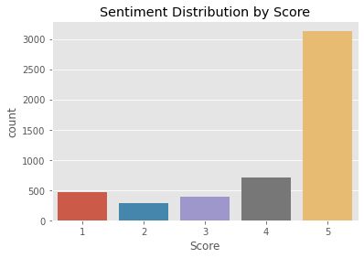
- Distribution:
- Text Cleaning:
Perform text data preprocessing by converting text to lowercase and removing special characters and numbers. Visualize the distribution of review lengths. Find and display the most common words in the tokenized reviews.
- Tokenization: Tokenize the preprocessed text using NLTK's word_tokenize.
- Stopwords: Stopwords are words that are commonly used in natural language but are often considered to be of little value in text analysis. Common examples of stopwords includes "the," "and," "in," "of," "is," "at," "on," and many others. Removing these stopwords can help reduce noise and improve the efficiency of text analysis.
- Lemmatization / Stemming: No
Ten Most Common Words with Occurrence
br: 5301
like: 2027
good: 1761
great: 1468
taste: 1402
one: 1334
product: 1276
flavor: 1201
coffee: 1116
chips: 1070
- Summary Statistics:
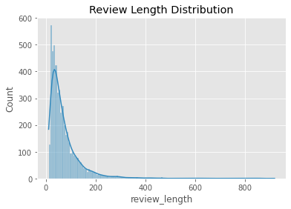

- Goal:
To find the overall consumer sentiment by analyzing customer reviews, star scores, and feedback length to understand customer sentiment and preferences.
- Proposed Methods
Utilize logistic regression to classify positive and negative reviews and identify the importance of specific words in sentiment prediction. Use topic modelling techniques like Latent Dirichlet Allocation (LDA) to identify common themes in customer feedback. Then Combine Random Forest and Gradient Boosting Classifier with VADER score to ensure accuracy of the result.
Data Citation
- J. McAuley and J. Leskovec. From amateurs to connoisseurs: modeling the evolution of user expertise through online reviews. WWW, 2013.
References
- Stanford Network Analysis Project

Attributes Classification

- Review Text:
  - Significance: The review text is the primary attribute for sentiment analysis. It contains the user-generated content that expresses sentiments, opinions, and reviews about Amazon products. Analyzing this attribute is crucial for understanding customer sentiment.
- Rating:
  - Significance: The product's rating, typically given on a scale of 1 to 5, provides a quantified representation of sentiment. High ratings (4 and 5) often indicate positive sentiment, while low ratings (1 and 2) indicate negative sentiment.
- Product ID:
  - Significance: The product ID can be used to group reviews by product. This is important when analyzing sentiments for specific products and comparing them. It also helps in identifying popular or controversial products.
- Review Title:
  - Significance: The review title often provides a concise summary of the sentiment expressed in the review text. Analyzing review titles can help in quick sentiment categorization and topic extraction.
- Helpfulness Numerator & Denominator:
  - Significance: The number of helpful votes indicates the relevance or quality of a review. Reviews with more helpful votes might be more influential, making them significant for sentiment analysis. A highly-rated helpful review may carry more weight in the sentiment analysis.
- Reviewer's ID:
  - Significance: The reviewer's ID can be used to identify and analyze reviews by specific users. This is important in identifying influential or frequent reviewers and their sentiment tendencies.
- Review Date:
  - Significance: Analyzing the review date can provide insights into how sentiment changes over time. It can help in identifying trends, product life cycles, and the impact of seasonal factors on sentiment.
- Review Length:
  - Significance: The length of a review can be indicative of the depth of sentiment expression. Longer reviews may contain more details and nuanced opinions, while shorter reviews may be concise expressions of sentiment.
- Verified Purchase:
  - Significance: Reviews from verified purchases are often more trustworthy. Analyzing sentiment in reviews from verified purchases can provide more reliable insights into product quality and customer satisfaction.
- Review Sentiment (Target):
  - Significance: This is the attribute to predict in the sentiment analysis task. It categorizes the review sentiment as positive, negative, or neutral based on the text and other attributes like the rating.

Exploratory Data Analysis

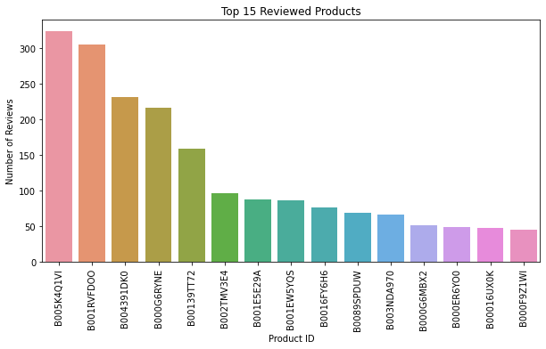

Product Popularity Bar Plot: The products represented by the top bars are the most popular or widely reviewed items in the dataset. Customers have left a substantial number of reviews for top 5 products. Popularity can be an indicator of consumer interest or the quality of the product, but it doesn't necessarily indicate the sentiment of the reviews (positive or negative).
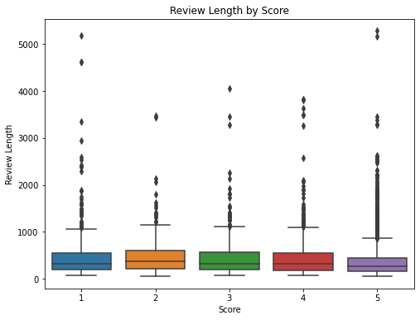

Box Plot of review length: Box plot shows reviews with higher scores (4 and 5) tend to have a wider spread of review lengths. There are fewer long length outliers in lower scores (1 and 2) than higher scores. More outliers in high review scores indicates many lengthy reviews exists, this suggests that consumers are more likely to provide detailed feedback when they have a positive experience with the product.

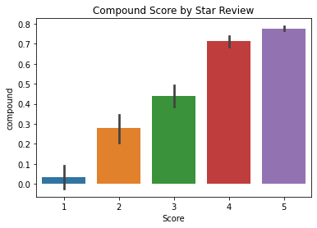
VADER Compound Score: Bar plot shows one star review has lower compound score while four and five star reviews is higher. This shows a positive correlation between higher star score and higher compound score as we expected.
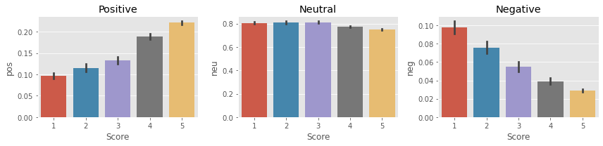
Positive Score: Barplot shows positive correlation as star score increases, positive score increases as well.
Neutral: Neutral score stays comparatively flat as expected.
Negative: Bar plot shows opposite correlation as star score decreases, negative score increases.

Approach

The previous research explores opinion mining and sentiment analysis on Amazon product reviews. Techniques include sentiment lexicons and feature-based sentiment classification. This project will build on those techniques to explore on the distribution of sentiment, comparing star ratings in relation to the topics and base on the accuracy of models, we will be able to identify actionable improvements associated with positive and negative themes. This will aid in understanding customer opinions and sentiment in product reviews, benefiting businesses in product development and recommendation.
Step 1: Data Preprocessing
- Collect and preprocess the customer review dataset, which may include text reviews, star scores, and feedback length.
- Remove irrelevant or duplicate reviews.
- Tokenize and clean the text data by removing stop words, punctuation, and special characters.
Step 2: Label Reviews
- Create labels for reviews based on star scores. For example, label reviews with 4 or 5 stars as positive and 1 or 2 stars as negative. Reviews with 3 stars can be considered neutral or excluded.
Step 3: Logistic Regression for Sentiment Classification
- Train a logistic regression model on the labelled reviews.
- Use features such as feedback length and the presence of specific words as predictors.
- Evaluate the model's accuracy, precision, recall, and F1 score to assess its performance in classifying reviews as positive or negative.
Step 4: Latent Dirichlet Allocation (LDA)
- Implement LDA to identify common topics or themes in customer feedback.
- This will help to understand what aspects of product or service customers are most concerned about.
Step 5: Feature Importance Analysis
- Analyze the importance of specific words or phrases in sentiment prediction using logistic regression.
- Identify words or phrases that strongly correlate with positive or negative sentiment.
Step 6: Combine Random Forest and Gradient Boosting
- Train Random Forest and Gradient Boosting classifiers to further enhance sentiment analysis.
- Utilize the features identified in Step 5 to improve the models' performance.
- Evaluate and compare the accuracy of the Random Forest and Gradient Boosting models.
Step 7: VADER Sentiment Analysis
- Integrate VADER sentiment analysis to improve accuracy.
- Calculate VADER scores to assess sentiment polarity.
- Compare VADER scores with the labels from Step 2 to see if there is agreement or disagreement.
Step 8: Aggregating Sentiment Analysis Results
- Combine the results from logistic regression, Random Forest, Gradient Boosting, and VADER to determine the overall consumer sentiment for each review.
- Consider the sentiment scores, topic modelling results, and LDA analysis to gain a comprehensive understanding of customer feedback.
Step 9: Visualize and Interpret the Results
- Visualize the sentiment analysis results and topic modelling outcomes.
- Interpret the findings to understand customer sentiment and preferences, including common themes and important words in positive and negative reviews.

Modeling Algorithms

- Logistic Regression
Logistic regression is a statistical method similar to linear regression that estimates the probability of a binary event occurring. Based on the given independent variables in a dataset the model predicts the probability a classification will occur using log odd ratios and an iterative maximum likelihood method (Hoffman, 2019).

- Random Forest Classifier
Random Forest classifier consists of a large number of individual decision tress that operate as a group or a ‘forest’. Each individual tree will classify and return a prediction and the prediction with the most votes will become the final prediction. The fundamental concept of random forest is majority wins and is beneficial in datasets where the attributes or predictor variables have low correlation. The idea of having multiple decision trees essentially protects the forest from individual error (Yiu, 2019).

- LDA (Latent Dirichlet Allocation)
LDA is widely employed for tasks such as document clustering, document summarization, and topic modeling.
In sentiment analysis, the main goal is to determine the sentiment or emotion expressed in a piece of text, such as positive, negative, or neutral.

- XGBoost Classifier
XGBoost stands for extreme gradient boosting, and is an implementation of gradient boosted decision trees designed for speed and performance. Gradient boosting is a technique where new models are created to correct the errors made by previous models. The results are combined to make the final prediction (Brownlee, 2016).

Results
Logistic Regression
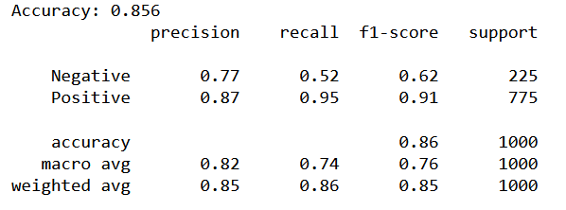
- The model performs well in identifying positive sentiment, with a high precision and recall for positive reviews (0.87 and 0.95, respectively).
- However, the model is less effective at identifying negative sentiment, as indicated by the lower precision (0.77) and recall (0.52) for negative reviews.
- The overall accuracy of 85.6% is decent, but since identifying negative sentiment is also important, we have to explore ways to improve model performance.
- The macro average and weighted average metrics provide an overall assessment. The macro average considers all classes equally, while the weighted average considers class imbalance.
LDA Topic Analysis
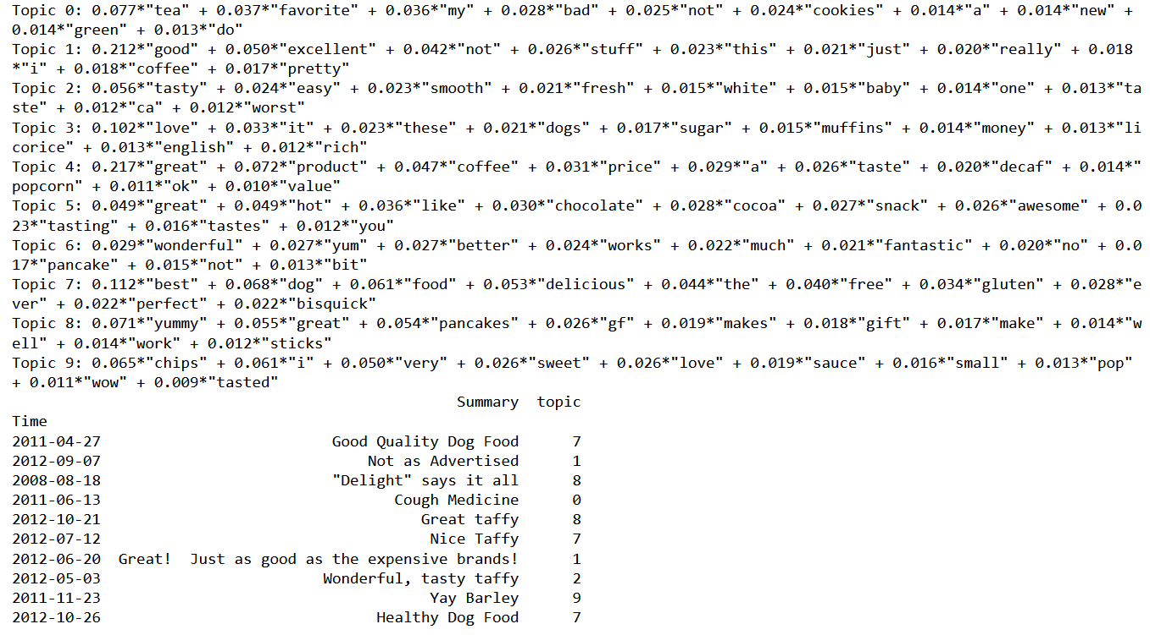
- The topics extracted by LDA represent various aspect of product reviews. For this specific dataset that mainly consists of animal food related products, the important topics for consumers are about freshness, flavours, packaging size, quality and value for money.

Feature Topic Importance Analysis
- The top words for positive sentiment reflect expressions of high quality, enthusiasm, and enjoyment associated with food or experiences.
- The top words for negative sentiment include descriptors that suggest dissatisfaction with taste, pricing, and possibly the overall experience.
Random Forest with Gradient Boosting
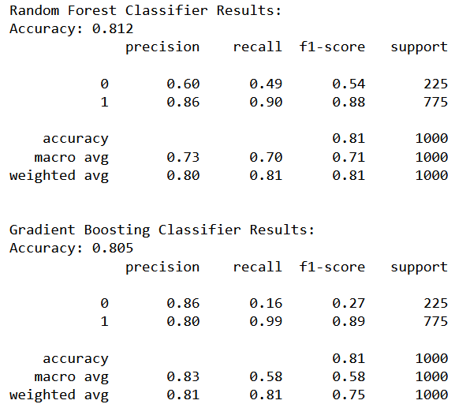
- Both models have a similar overall accuracy, but their strengths and weaknesses differ.
- The Random Forest Classifier performs better in identifying negative sentiment (higher recall) but sacrifices precision, resulting in a lower F1-Score for negative sentiment.
- The Gradient Boosting Classifier excels in precision for negative sentiment but has low recall, leading to a lower F1-Score for negative sentiment.
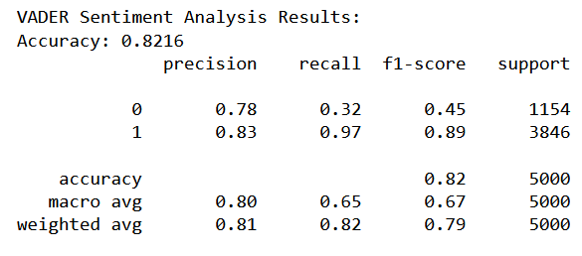
VADER Sentiment Score
- The VADER sentiment analysis model is relatively better at identifying positive sentiment, with high precision and recall, suggesting that it is effective at capturing positive expressions in the text.
- However, the model struggles with negative sentiment, as indicated by the lower recall for the negative class. It tends to miss negative instances, leading to a lower F1-Score for negative sentiment.

Conclusion & Recommendation

For the sentiment analysis on this specific dataset which focuses on various animal food related products, logistic regression yielded best performance of 85.6% accuracy after filtering stop words and topic considerations. Each model exhibited strengths and weaknesses in practice, emphasizing the importance of understanding specific business requirements and business decision priorities. Logistic regression and random forest excelled in positive sentiment identification, while gradient boosting showed high precision for negative sentiment. VADER, LDA and feature importance analysis provided insights into topics and influential words associated with consumer buying decision-making processes.
For in-depth practical applications, the choice of the model depends on the specific goals of sentiment analysis and the importance of precision, recall, or overall accuracy in different contexts, this requires more fine tuning and combination models for optimizing performance.

References

- Pang, B., & Lee, L. (2008). Opinion mining and sentiment analysis. Foundations and Trends® in Information Retrieval, 2(1-2), 1-135.
- Liu, B. (2015). Sentiment analysis: Mining opinions, sentiments, and emotions. Cambridge University Press.
- Manning, C. D., Raghavan, P., & Schütze, H. (2008). Introduction to information retrieval. Cambridge University Press.
- Bird, S., Klein, E., & Loper, E. (2009). Natural language processing with Python: Analyzing text with the natural language toolkit. O'Reilly Media.
- Jurafsky, D., & Martin, J. H. (2020). Speech and language processing (3rd ed.). Pearson.
- Cambria, E. (2016). Affective computing and sentiment analysis. Elsevier.
- Aggarwal, C. C. (2012). Sentiment analysis and opinion mining. Morgan & Claypool Publishers.
- Manning, C. D., & Schütze, H. (1999). Foundations of statistical natural language processing. MIT Press.
- Hutto, C. J., & Gilbert, E. (2014). VADER: A parsimonious rule-based model for sentiment analysis of social media text. In Proceedings of the Eighth International Conference on Weblogs and Social Media.
- Raschka, S., & Mirjalili, V. (2019). Python machine learning: Machine learning and deep learning with Python, scikit-learn, and TensorFlow (3rd ed.). Packt Publishing.

